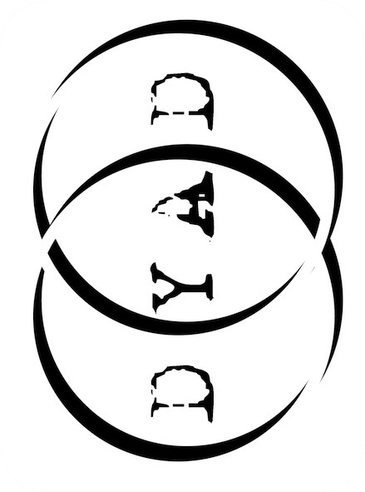 Dyad Productions

The Unremarkable Death of

# Marilyn Monroe

# PRESS RELEASE

**Dyad Productions**

Written and directed by Elton Townend Jones

Performed by Lizzie Wort

From Dyad Productions, the company that brought you *Female Gothic*, *I, Elizabeth*, *The Diaries of Adam and Eve* and *Austen’s Women.*

August 2nd, 1962…

Monroe as we’ve never seen her before: alone in her bedroom in a dressing gown and underwear; no glitz, no glamour, no masks. Overdosed on pills, the woman behind the icon unravels her remarkable life and travels back through the memories of her closest relationships. Repeatedly stalked by a mysterious caller, the Hollywood icon tells all (Joe DiMaggio, Clark Gable, Arthur Miller, her mother – it’s all here), revealing a biting intelligence and an imperfect body, and leads us in real time to the very moment of her death.

Dyad Productions creates, produces and tours classic theatre with an innovative and contemporary emphasis. This radical interpretation of one of the world’s most famous women is Dyad’s fifth original production in as many years, and, although a work of fiction, exposes the truth behind the legend.

Previous works, *Austen’s Women* and *I, Elizabeth* were five-star successes at Edinburgh and Adelaide in 2009/2010 and 2010/2011, with *The Diaries of Adam and Eve* and *Female Gothic* garnering five-star reviews at Edinburgh 2011 and 2012, respectively. All four plays continue to tour across the UK and internationally, while *Austen’s Women* returned to Edinburgh for a limited sell-out run at Assembly in 2013.

*The Unremarkable Death of Marilyn Monroe* is written and directed by Elton Townend Jones (writer/performer: *The Diaries of Adam and Eve*,script editor: *Female Gothic,* writer: *Cutting the Cord* for Flying Eye*)*, performed by Lizzie Wort (*Animal Farm* – Guy Masterson/TTI; *The Magician’s Daughter* – RSC/Little Angel Theatre) and produced by Rebecca Vaughan (writer/performer: *Austen’s Women*, *I, Elizabeth*, *Female Gothic*, performer: *The Diaries of Adam and Eve*).

★★★★★ ‘Simply stunning.’ (**Edinburgh Reporter**)

★★★★★ ‘Spellbinding’ (**The Carrick**)

★★★★★ ‘Outstanding (**One4Review**)

★★★★ ‘Anything but unremarkable’ (**Three Weeks**)

★★★★ ‘Fantastic’ (**Broadway Baby**)

★★★★ ‘Powerful and poetic… a dazzling performance’ (**Edinburgh Guide**)

★★★★ ‘Outstanding.’ (**Quotidian Times**)

★★★★ ‘Immaculate.’ (**A Younger Theatre**)

‘Handles Marilyn’s life with intelligence and compassion’ (**The Stage**)